Data preparation
Imputation using also center
Same data split for all outcomes stratified by OS censoring status
Encoding:
- # Hystology clear cell (1=clear cell, 0=papillary, chromophobe or other)
X_train_imputed['histology_clearcell'] = (X_train_imputed['hystology'] == 1).astype(int)
- # Line of therapy 2 (1=lot 2, 0=lot >2)
X_train_imputed['Nivo_2ndline'] = (X_train_imputed['Line of therapy'] == 2).astype(int)
Different logarithmic tranformations

Nested cross validation
https://scikit-learn.org/stable/auto_examples/model_selection/plot_nested_cross_validation_iris.html
Nested CV effectively uses a series of train/validation/test set splits.
In the inner loop (GridSearchCV), the score is approximately maximized by fitting a model to each training set, and then directly maximized in selecting (hyper)parameters over the validation set.
In the outer loop (cross_val_score), generalization error is estimated by averaging test set scores over several dataset splits.

https://medium.com/@pacosun/nested-cross-validation-your-weapon-against-overfitting-17401c851593
Two loops of nested cross-validation:
- Outer loop model evaluation (estimating how well the final model will generalize)
For each fold, we hold out a chunk of data to evaluate the performance of the model after it has been tuned
- Inner loop model selection (choosing the best hyperparameters or model type)
Within the training data from the outer loop, we perform another cross-validation to tune hyperparameters
This way, each performance score from the outer loop is based on data the model never saw during tuning.

https://machinelearningmastery.com/nested-cross-validation-for-machine-learning-with-python/
It is common to use a smaller value of k for the inner loop.

https://journals.plos.org/plosone/article?id=10.1371/journal.pone.0261401#pone.0261401.ref025
https://link.springer.com/article/10.1186/1758-2946-6-10
https://towardsdatascience.com/how-cross-validation-can-go-wrong-and-how-to-fix-it-feature-selection-use-case-with-sample-code-abf928be9080/
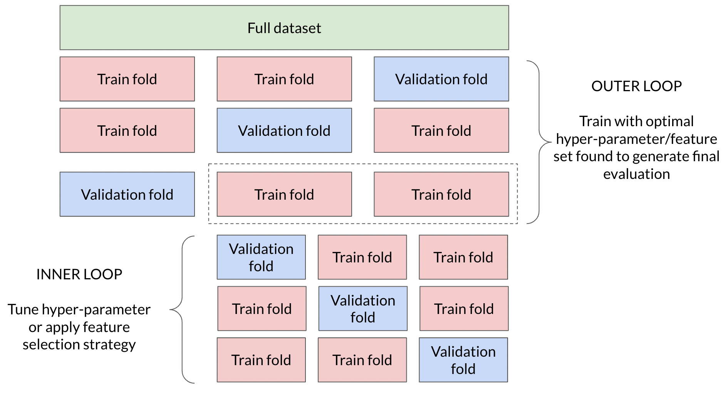

Pipeline
https://apxml.com/courses/getting-started-with-scikit-learn/chapter-6-building-pipelines/grid-search-pipelines
https://scikit-learn.org/stable/modules/compose.html
https://www.geeksforgeeks.org/machine-learning/performing-feature-selection-with-gridsearchcv-in-sklearn/

